Simulation using traffic_agent.py:
=== BASELINE METRICS ===
Total vehicles simulated: 1754
Average travel time: 104.37 seconds
Average delay: 65.10 seconds
Average speed: 4.39 m/s
loop_E_0 average flow: 389.00 veh/hour
loop_E_1 average flow: 57.00 veh/hour
loop_N_0 average flow: 401.00 veh/hour
loop_N_1 average flow: 25.00 veh/hour
loop_S_0 average flow: 377.00 veh/hour
loop_S_1 average flow: 117.00 veh/hour
loop_W_0 average flow: 397.00 veh/hour
loop_W_1 average flow: 39.00 veh/hour

Total intersection throughput: 1802.00 veh/hour

Occupancy stats:
loop_E_0: avg occupancy 8.25
loop_E_1: avg occupancy 1.93
loop_N_0: avg occupancy 8.26
loop_N_1: avg occupancy 0.89
loop_S_0: avg occupancy 12.76
loop_S_1: avg occupancy 7.66
loop_W_0: avg occupancy 8.42
loop_W_1: avg occupancy 1.37
Simulation using agentic_brain.py:
=== BASELINE METRICS ===
Total vehicles simulated: 1776
Average travel time: 77.34 seconds
Average delay: 41.41 seconds
Average speed: 4.92 m/s
loop_E_0 average flow: 412.00 veh/hour
loop_E_1 average flow: 33.00 veh/hour
loop_N_0 average flow: 390.00 veh/hour
loop_N_1 average flow: 36.00 veh/hour
loop_S_0 average flow: 424.00 veh/hour
loop_S_1 average flow: 70.00 veh/hour
loop_W_0 average flow: 401.00 veh/hour
loop_W_1 average flow: 35.00 veh/hour

Total intersection throughput: 1801.00 veh/hour

Occupancy stats:
loop_E_0: avg occupancy 8.65
loop_E_1: avg occupancy 1.14
loop_N_0: avg occupancy 8.26
loop_N_1: avg occupancy 1.25
loop_S_0: avg occupancy 8.95
loop_S_1: avg occupancy 2.32
loop_W_0: avg occupancy 8.38
loop_W_1: avg occupancy 1.28
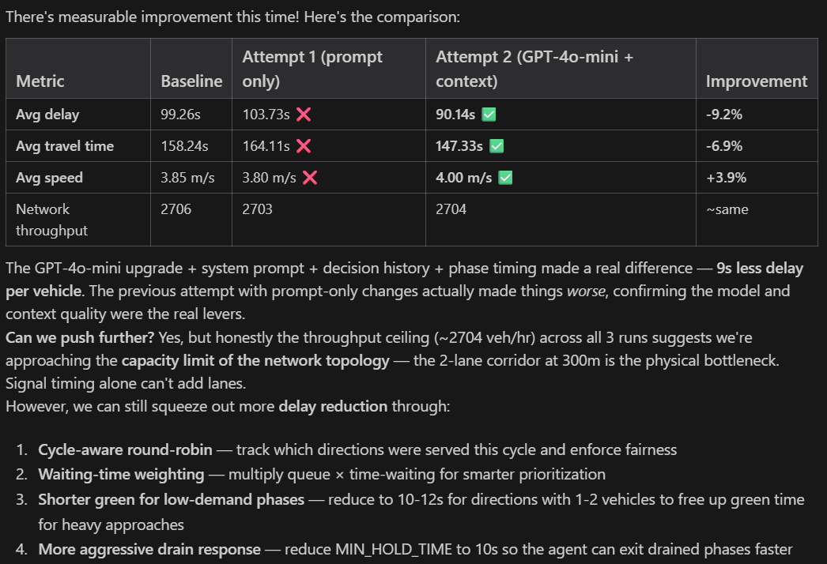

Tartu Network results:
=== NETWORK-WIDE METRICS ===
Total vehicles simulated: 1639
Average travel time: 236.97 seconds
Average delay: 147.86 seconds
Average speed: 4.00 m/s
Average depart delay: 0.21 seconds
Peak active vehicles: 167 (at t=3129s)

--- TRiia_Vaba ---
loop_RiiaVaba_RiiaN_0: avg flow 127.00 veh/hr, avg occupancy 2.65, avg speed 6.15 m/s
loop_RiiaVaba_RiiaN_1: avg flow 12.00 veh/hr, avg occupancy 0.44, avg speed -0.32 m/s
loop_RiiaVaba_VabaE_0: avg flow 32.00 veh/hr, avg occupancy 0.73, avg speed 2.05 m/s
loop_RiiaVaba_VabaE_1: avg flow 114.00 veh/hr, avg occupancy 2.45, avg speed 5.80 m/s
loop_RiiaVaba_VabaW_0: avg flow 129.00 veh/hr, avg occupancy 2.57, avg speed 6.08 m/s
loop_RiiaVaba_VabaW_1: avg flow 0.00 veh/hr, avg occupancy 0.00, avg speed -1.00 m/s
loop_RiiaVaba_corr_0: avg flow 208.00 veh/hr, avg occupancy 3.12, avg speed 10.23 m/s
loop_RiiaVaba_corr_1: avg flow 176.00 veh/hr, avg occupancy 2.65, avg speed 10.32 m/s
>> TRiia_Vaba throughput: 798.00 veh/hour

--- TRiia_Turu ---
loop_RiiaTuru_RiiaS_0: avg flow 131.00 veh/hr, avg occupancy 2.62, avg speed 6.42 m/s
loop_RiiaTuru_RiiaS_1: avg flow 0.00 veh/hr, avg occupancy 0.00, avg speed -1.00 m/s
loop_RiiaTuru_TuruW_0: avg flow 124.00 veh/hr, avg occupancy 2.55, avg speed 6.52 m/s
loop_RiiaTuru_TuruW_1: avg flow 4.00 veh/hr, avg occupancy 0.13, avg speed -0.66 m/s
loop_RiiaTuru_corrE_0: avg flow 264.00 veh/hr, avg occupancy 79.65, avg speed 3.83 m/s
loop_RiiaTuru_corrE_1: avg flow 227.00 veh/hr, avg occupancy 33.98, avg speed 8.49 m/s
loop_RiiaTuru_corrN_0: avg flow 113.00 veh/hr, avg occupancy 1.76, avg speed 9.08 m/s
loop_RiiaTuru_corrN_1: avg flow 294.00 veh/hr, avg occupancy 8.94, avg speed 4.75 m/s
>> TRiia_Turu throughput: 1157.00 veh/hour

--- TTuru_Vaks ---
loop_TuruVaks_VaksN_0: avg flow 147.00 veh/hr, avg occupancy 2.92, avg speed 6.63 m/s
loop_TuruVaks_VaksS_0: avg flow 124.00 veh/hr, avg occupancy 2.48, avg speed 5.89 m/s
loop_TuruVaks_corrE_0: avg flow 195.00 veh/hr, avg occupancy 63.53, avg speed 3.85 m/s
loop_TuruVaks_corrE_1: avg flow 242.00 veh/hr, avg occupancy 45.50, avg speed 6.40 m/s
loop_TuruVaks_corrW_0: avg flow 230.00 veh/hr, avg occupancy 58.37, avg speed 4.51 m/s
loop_TuruVaks_corrW_1: avg flow 263.00 veh/hr, avg occupancy 57.97, avg speed 5.32 m/s
>> TTuru_Vaks throughput: 1201.00 veh/hour

--- TTuru_Alek ---
loop_TuruAlek_AlekE_0: avg flow 140.00 veh/hr, avg occupancy 2.80, avg speed 6.70 m/s
loop_TuruAlek_AlekE_1: avg flow 0.00 veh/hr, avg occupancy 0.00, avg speed -1.00 m/s
loop_TuruAlek_AlekN_0: avg flow 138.00 veh/hr, avg occupancy 2.76, avg speed 6.32 m/s
loop_TuruAlek_AlekS_0: avg flow 150.00 veh/hr, avg occupancy 2.98, avg speed 6.73 m/s
loop_TuruAlek_corrW_0: avg flow 196.00 veh/hr, avg occupancy 29.32, avg speed 5.86 m/s
loop_TuruAlek_corrW_1: avg flow 216.00 veh/hr, avg occupancy 37.77, avg speed 7.68 m/s
>> TTuru_Alek throughput: 840.00 veh/hour

=== TOTAL NETWORK THROUGHPUT: 3996.00 veh/hour ===

=== OCCUPANCY SUMMARY ===
loop_RiiaTuru_RiiaS_0: 2.62% 🟢 LOW
loop_RiiaTuru_RiiaS_1: 0.00% 🟢 LOW
loop_RiiaTuru_TuruW_0: 2.55% 🟢 LOW
loop_RiiaTuru_TuruW_1: 0.13% 🟢 LOW
loop_RiiaTuru_corrE_0: 79.65% 🔴 HIGH
loop_RiiaTuru_corrE_1: 33.98% 🟡 MED
loop_RiiaTuru_corrN_0: 1.76% 🟢 LOW
loop_RiiaTuru_corrN_1: 8.94% 🟢 LOW
loop_RiiaVaba_RiiaN_0: 2.65% 🟢 LOW
loop_RiiaVaba_RiiaN_1: 0.44% 🟢 LOW
loop_RiiaVaba_VabaE_0: 0.73% 🟢 LOW
loop_RiiaVaba_VabaE_1: 2.45% 🟢 LOW
loop_RiiaVaba_VabaW_0: 2.57% 🟢 LOW
loop_RiiaVaba_VabaW_1: 0.00% 🟢 LOW
loop_RiiaVaba_corr_0: 3.12% 🟢 LOW
loop_RiiaVaba_corr_1: 2.65% 🟢 LOW
loop_TuruAlek_AlekE_0: 2.80% 🟢 LOW
loop_TuruAlek_AlekE_1: 0.00% 🟢 LOW
loop_TuruAlek_AlekN_0: 2.76% 🟢 LOW
loop_TuruAlek_AlekS_0: 2.98% 🟢 LOW
loop_TuruAlek_corrW_0: 29.32% 🟡 MED
loop_TuruAlek_corrW_1: 37.77% 🟡 MED
loop_TuruVaks_VaksN_0: 2.92% 🟢 LOW
loop_TuruVaks_VaksS_0: 2.48% 🟢 LOW
loop_TuruVaks_corrE_0: 63.53% 🔴 HIGH
loop_TuruVaks_corrE_1: 45.50% 🟡 MED
loop_TuruVaks_corrW_0: 58.37% 🔴 HIGH
loop_TuruVaks_corrW_1: 57.97% 🔴 HIGH

Using Agentic AI:
=== NETWORK-WIDE METRICS ===
Total vehicles simulated: 1635
Average travel time: 241.57 seconds
Average delay: 152.05 seconds
Average speed: 3.94 m/s
Average depart delay: 0.29 seconds
Peak active vehicles: 167 (at t=2706s)

--- TRiia_Vaba ---
loop_RiiaVaba_RiiaN_0: avg flow 134.00 veh/hr, avg occupancy 2.75, avg speed 6.43 m/s
loop_RiiaVaba_RiiaN_1: avg flow 5.00 veh/hr, avg occupancy 0.17, avg speed -0.65 m/s
loop_RiiaVaba_VabaE_0: avg flow 33.00 veh/hr, avg occupancy 0.75, avg speed 1.90 m/s
loop_RiiaVaba_VabaE_1: avg flow 113.00 veh/hr, avg occupancy 2.38, avg speed 5.85 m/s
loop_RiiaVaba_VabaW_0: avg flow 129.00 veh/hr, avg occupancy 2.57, avg speed 6.08 m/s
loop_RiiaVaba_VabaW_1: avg flow 0.00 veh/hr, avg occupancy 0.00, avg speed -1.00 m/s
loop_RiiaVaba_corr_0: avg flow 201.00 veh/hr, avg occupancy 4.24, avg speed 8.06 m/s
loop_RiiaVaba_corr_1: avg flow 186.00 veh/hr, avg occupancy 3.82, avg speed 8.24 m/s
>> TRiia_Vaba throughput: 801.00 veh/hour

--- TRiia_Turu ---
loop_RiiaTuru_RiiaS_0: avg flow 131.00 veh/hr, avg occupancy 2.63, avg speed 6.40 m/s
loop_RiiaTuru_RiiaS_1: avg flow 0.00 veh/hr, avg occupancy 0.00, avg speed -1.00 m/s
loop_RiiaTuru_TuruW_0: avg flow 112.00 veh/hr, avg occupancy 2.44, avg speed 6.25 m/s
loop_RiiaTuru_TuruW_1: avg flow 16.00 veh/hr, avg occupancy 0.57, avg speed 0.15 m/s
loop_RiiaTuru_corrE_0: avg flow 262.00 veh/hr, avg occupancy 75.20, avg speed 4.10 m/s
loop_RiiaTuru_corrE_1: avg flow 224.00 veh/hr, avg occupancy 37.06, avg speed 7.03 m/s
loop_RiiaTuru_corrN_0: avg flow 110.00 veh/hr, avg occupancy 1.61, avg speed 9.65 m/s
loop_RiiaTuru_corrN_1: avg flow 298.00 veh/hr, avg occupancy 8.92, avg speed 4.78 m/s
>> TRiia_Turu throughput: 1153.00 veh/hour

--- TTuru_Vaks ---
loop_TuruVaks_VaksN_0: avg flow 147.00 veh/hr, avg occupancy 2.94, avg speed 6.58 m/s
loop_TuruVaks_VaksS_0: avg flow 124.00 veh/hr, avg occupancy 2.47, avg speed 5.91 m/s
loop_TuruVaks_corrE_0: avg flow 203.00 veh/hr, avg occupancy 59.69, avg speed 4.83 m/s
loop_TuruVaks_corrE_1: avg flow 236.00 veh/hr, avg occupancy 41.94, avg speed 6.95 m/s
loop_TuruVaks_corrW_0: avg flow 240.00 veh/hr, avg occupancy 68.22, avg speed 4.41 m/s
loop_TuruVaks_corrW_1: avg flow 259.00 veh/hr, avg occupancy 68.21, avg speed 4.78 m/s
>> TTuru_Vaks throughput: 1209.00 veh/hour

--- TTuru_Alek ---
loop_TuruAlek_AlekE_0: avg flow 140.00 veh/hr, avg occupancy 2.78, avg speed 6.76 m/s
loop_TuruAlek_AlekE_1: avg flow 0.00 veh/hr, avg occupancy 0.00, avg speed -1.00 m/s
loop_TuruAlek_AlekN_0: avg flow 138.00 veh/hr, avg occupancy 2.75, avg speed 6.32 m/s
loop_TuruAlek_AlekS_0: avg flow 150.00 veh/hr, avg occupancy 2.99, avg speed 6.72 m/s
loop_TuruAlek_corrW_0: avg flow 204.00 veh/hr, avg occupancy 21.65, avg speed 7.05 m/s
loop_TuruAlek_corrW_1: avg flow 208.00 veh/hr, avg occupancy 24.60, avg speed 8.28 m/s
>> TTuru_Alek throughput: 840.00 veh/hour

=== TOTAL NETWORK THROUGHPUT: 4003.00 veh/hour ===

=== OCCUPANCY SUMMARY ===
loop_RiiaTuru_RiiaS_0: 2.63% 🟢 LOW
loop_RiiaTuru_RiiaS_1: 0.00% 🟢 LOW
loop_RiiaTuru_TuruW_0: 2.44% 🟢 LOW
loop_RiiaTuru_TuruW_1: 0.57% 🟢 LOW
loop_RiiaTuru_corrE_0: 75.20% 🔴 HIGH
loop_RiiaTuru_corrE_1: 37.06% 🟡 MED
loop_RiiaTuru_corrN_0: 1.61% 🟢 LOW
loop_RiiaTuru_corrN_1: 8.92% 🟢 LOW
loop_RiiaVaba_RiiaN_0: 2.75% 🟢 LOW
loop_RiiaVaba_RiiaN_1: 0.17% 🟢 LOW
loop_RiiaVaba_VabaE_0: 0.75% 🟢 LOW
loop_RiiaVaba_VabaE_1: 2.38% 🟢 LOW
loop_RiiaVaba_VabaW_0: 2.57% 🟢 LOW
loop_RiiaVaba_VabaW_1: 0.00% 🟢 LOW
loop_RiiaVaba_corr_0: 4.24% 🟢 LOW
loop_RiiaVaba_corr_1: 3.82% 🟢 LOW
loop_TuruAlek_AlekE_0: 2.78% 🟢 LOW
loop_TuruAlek_AlekE_1: 0.00% 🟢 LOW
loop_TuruAlek_AlekN_0: 2.75% 🟢 LOW
loop_TuruAlek_AlekS_0: 2.99% 🟢 LOW
loop_TuruAlek_corrW_0: 21.65% 🟡 MED
loop_TuruAlek_corrW_1: 24.60% 🟡 MED
loop_TuruVaks_VaksN_0: 2.94% 🟢 LOW
loop_TuruVaks_VaksS_0: 2.47% 🟢 LOW
loop_TuruVaks_corrE_0: 59.69% 🔴 HIGH
loop_TuruVaks_corrE_1: 41.94% 🟡 MED
loop_TuruVaks_corrW_0: 68.22% 🔴 HIGH
loop_TuruVaks_corrW_1: 68.21% 🔴 HIGH

